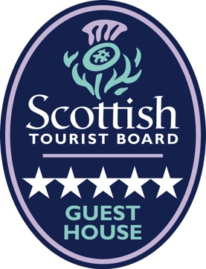
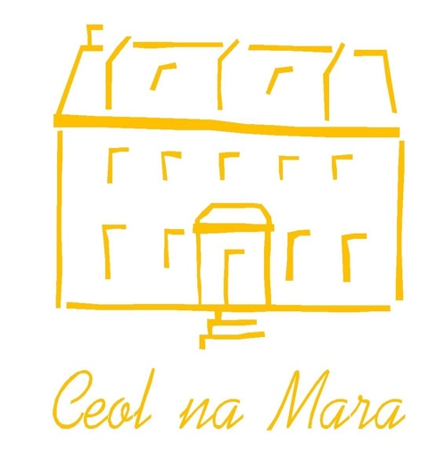

Accessibility Guide for Ceol na Mara Guest House
contact@ceolnamara.com, 01859 502464, www.ceolnamara.com
Contact for accessibility enquiries: David Loomes

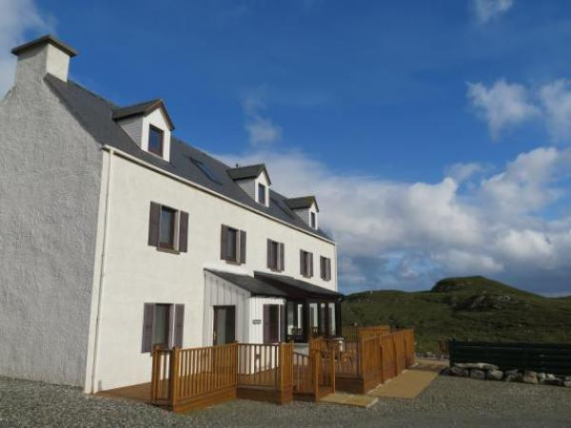

Welcome
Ceol na Mara is an award-winning 5* B&B, set in a former converted Croft House dating back to 1910. Surrounded by our 50 acre croft we enjoy privacy and seclusion, and are ideally locoated for exploring both Harris and Lewis. Please see our website www.ceolnamara.com for lots of information and details.

At a Glance

Level Access
- The main entrance has 3 steps. There is no lift and no ramp.
- There is level access once in entrance hall to:
  - Dining Table

Access with steps
- There are steps from the main entrance porch to the:
  - Bedrooms
  - Dining Room
  - Seating area (Guest Lounges)

Bedrooms
- We have non-allergic bedding available on request.

Hearing
- The (bedroom) TVs have subtitles.
- All staff have disability awareness and Next Generation Text training.

Visual
- Some parts of the venue have low lighting.

General
- Staff are available 24 hours a day (contact by telephone).
- All staff have disability awareness training.
- We have emergency evacuation procedures for disabled visitors.

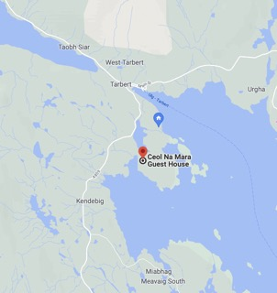
Getting here
Ceol na Mara Guest House
7 Direcleit
Isle of Harris
HS3 3DP

Travel by public transport
- You can get to Ceol na Mara Guest House by car, bus, or walking, and to Tarbert by ferry.
- The bus stops at the junction of the A859 and our lane, which is 0.50 miles/0.8km from Ceol na Mara Guest House.
- The nearest port is Tarbert Ferry Terminal, CalMac. The port is 1.5 miles/2.4 km from Ceol na Mara Guest House.

Travel by taxi
- You can get a taxi from Harris Taxis by calling 07500450387.

Parking
- We have a car park. The parking is less than 50 metres from the main entrance, and is free.
- There is a drop-off point at the main entrance. The drop-off point does not have a dropped kerb.
- From the parking to the main entrance, there are 3 steps. There is no ramp and no lift.
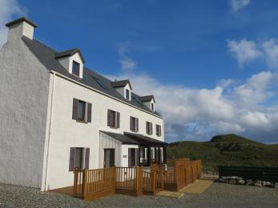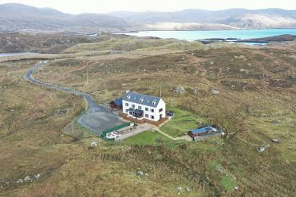
Ceol na Mara – Entrance Ceol na Mara in the landscape

Arrival

Path to main entrance
- From the car park to the main entrance, there are 3 steps. There is no ramp and no lift.

Main entrance
- The door is 800mm wide.
- The main entrance has 1 step.
- The main door is side hung and manual.

Getting around inside

Room Locations:
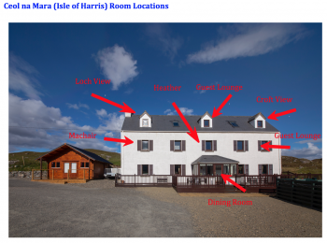

Visual Impairment - General Information
- Some parts of the venue have low lighting.

Bedrooms
- All bedrooms have windows.
- Bedrooms have ceiling lights, bedside lamps and desk or table lamps.
- Lights are halogen, LED and energy saving. Some lights can be controlled independently.
- TVs have subtitles.
- All bedrooms are non-smoking.
- All bedrooms have fitted carpets.
- We have non-allergic bedding with synthetic on request, and we can give details of our cleaning products on request too.
- No bedrooms have level access. The bedroom nearest the main entrance has 15 steps.
- We have bathrooms with a separate shower (no baths).

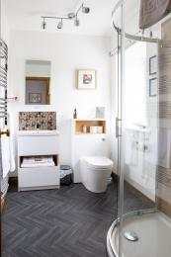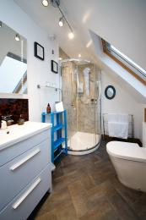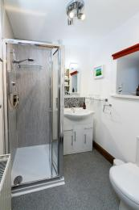
Machair Ensuite Loch View Ensuite Heather

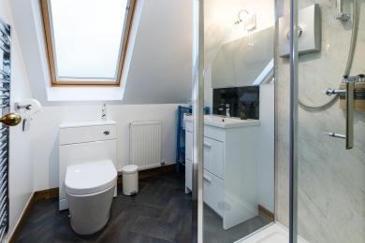
Croft View Ensuite

Lounges
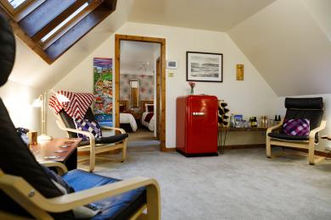
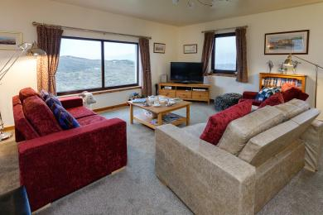

Main Guest Lounge (middle floor) Upper Guest Lounge (upper/top floor)

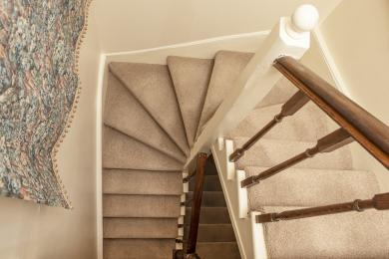
Staircase

Place to eat and drink

Dining Room
- The route is 800mm wide, or more. From the main entrance to the dining area, there is 1 step. There is no lift and no ramp.
- To get to a table, there are no steps once in the Entrance Hall.
- There is background music.
- The table and plates have high colour contrast.
- We cater for sugar free (diabetic), vegetarian, gluten free (celiacs), lactose free (dairy free), nut free and vegan specific diets.

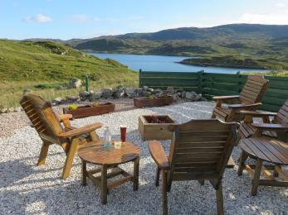
Getting around outside

Seating area
- The route is 1200mm wide, or more.
- From the main entrance to the gardens, there are 3 steps.
There is no lift and no ramp.

Customer care support

Accessibility equipment
- The nearest toilet for assistance dogs is 20m from the main house (on the Croft land, though please be aware that sheep, Highland Cattle and horses regularly graze this land).

Customer care support
- All staff have disability awareness training.
- All staff have Next Generation Text training.
- Staff are available 24 hours a day.
- Staff live on site - contact by phone or doorbell.

Guide last updated: 19th December 2022

